OPEN MEETING SAILING INSTRUCTIONS

1. RULES: The event will be governed by the rules as defined in The Racing Rules of Sailing, RYA Prescriptions, Class Rules and these Sailing Instructions.

2. NOTICES TO COMPETITORS: Notices to competitors will be posted on the Official Notice Board located at the lower entrance to the clubhouse adjacent to the main club flagstaff and wet bar.

3. CHANGES TO SAILING INSTRUCTIONS: Any change to the Sailing Instructions will be posted at least 30 minutes before the first warning signal on the day it will take effect and shall be valid for all subsequent races in the series unless notified to the contrary.

4. SIGNALS MADE ASHORE: Signals made ashore will be displayed on the club flagstaff.

When flag AP is displayed ashore, ‘1 minute’ is replaced with ‘not less than 30 minutes’ in the race signals AP.

Competitors should note that signals may be flown from halyards at the club flagstaff in connection with the control of club racing.

5. SCHEDULE OF RACES: 4 races are scheduled - 2 races back to back, lunch ashore followed by 2 races back to back

6. CLASS FLAGS: Class flags will be posted on the Official Notice Board.

7. EXCLUSION AREAS: Boats shall not sail at any time within 30 metres of the shore except at the club compound. Landing in an exclusion area is allowed only in an emergency.

The pontoon and moorings in front of the clubhouse are for use only by official boats.

8. THE COURSES: The diagrams in Addendum A show the courses, the order in which marks are to be passed, and the side on which the mark is to be left.
The Gate/finish line should not be sailed through on the downwind leg. The gate will be between the committee boat and dan buoy displaying a blue flag.

9. THE MARKS: The marks will be cylindrical in shape and coloured orange unless otherwise stated in Addendum A.

10. AREAS THAT ARE OBSTRUCTIONS: The following areas are designated as obstructions:
- Fishing boats, whether engaged in fishing or not. For this purpose, the area within which a fishing line extends from, or is being cast from a fishing boat, shall form a part of the fishing boat.
- Rescue boats and committee boats when not displaying definitive start or finish flags.
- 30 metres of the shore except at the club compound.

11. THE START: The starting line will be between a staff displaying an orange flag or shape on the race committee boat and a starting mark.

Boats whose warning signal has not been made should avoid the starting area during the starting sequence for other races.

A boat that does not start within 4 minutes after her starting signal will be scored Did Not Start without a hearing. This changes RRS A4 and A5.

A race may not be started if, in the opinion of the Race Officer, there is excessive or insufficient wind.

12. CHANGE OF THE NEXT LEG OF THE COURSE: The position of marks may be changed during a race in the event of a wind change. Such change will be made only if no boat is sailing towards the mark on that leg of the course. Flag C will not normally be flown to indicate any change, nor will “+”or “-“signs be displayed. This changes RRS rule 33.

13. THE FINISH: The finishing line will be between a staff displaying a blue flag or shape on a race committee boat and the finish mark, dan buoy displaying a blue flag.

If the course is shortened this may be at a rounding mark (as RRS 32.2(a)). Alternatively, if the committee boat is on station on the finishing line and displays the shortened course flag, boats should complete the lap, and cross the finishing line to finish. This changes RRS 32.2. If necessary, the class flag(s) will also be displayed.

At the discretion of the race officer, any competitor failing to finish within a reasonable time period of the first boat finishing that race may be finished on the course by a committee boat or safety boat displaying International Code Flag W. Any competitor so finished will score the number of points in accordance to their finishing position in that race. This changes RRS 28.1.

14. TIME LIMIT: The time limit will be two hours from the start for that class. Boats failing to finish within 30 minutes after the first boat of her class finishes or within the time limit, whichever is later will be scored “Did not finish”. This changes RRS 35.

15. DECLARATIONS: There is no requirement to sign on or off unless declaring penalties or retirement. The declaration sheets are on the official notice board and the standard codes of RRS Appendix A11 will be used.

16. PROTESTS AND REQUESTS FOR REDRESS: Protests shall be written on forms available at the race office and delivered there within 30 minutes after the time of the last boat’s finish, except when races have been notified to competitors as being run back-to-back. In this case protests for all 'back-to-back' races must be made within 30 minutes of the time the last boat finishes the last race. The race committee may extend the time limit in exceptional circumstances.
- The exoneration penalty and RYA arbitration procedures of the RYA rules disputes procedures will be available. See the Official Notice Board for details.
- The jury will hear protests in approximately the order of receipt as soon as possible.
- RRS 66 is changed by adding this sentence: “On the last day of racing, a party to a hearing may ask for a reopening no later than 30 minutes after being informed of the decision”.

17. SCORING: The low point scoring system rule A4 will apply, modified so that each boat’s series score will be the total of her race scores with her worst score discarded if 4 races have been completed. The scheduled number of races will be published on the Official Notice Board.

18. SAFETY REGULATIONS: Adequate personal buoyancy shall be worn at all times whilst on the water. Wet suits and dry suits are not adequate personal buoyancy. This changes Rule 40.

During the months of November, December, January, February and March, all persons on the water shall wear exposure proof clothing. For the purpose of this instruction ‘Exposure proof clothing’ shall mean an adequate expanded neoprene wet suit providing protection from neck to ankle or a dry suit providing watertight cover from neck to ankle.

19. SUPPORT BOATS: No support boats are permitted on the water.

20. RADIO COMMUNICATIONS: Except in an emergency, a boat that is racing shall not make voice or data transmissions and shall not receive voice or data communication that is not available to all boats.

21. DISCLAIMER OF LIABILITY: Competitors participate in the event entirely at their own risk. See rule 4, Decision to Race.

The safety of a boat and her entire management, including insurance, shall be the sole responsibility of the owner/person in charge who must ensure that the boat and crew are adequate to face the conditions that may arise in the course of the regatta. Neither these sailing instructions nor any inspection of the boat limits or reduces the absolute responsibility of the owner/person in charge for the boat, the crew, and her management. Neither the race organisers nor Draycote Water Sailing Club shall accept any liability for any loss, material damage or personal injury or death sustained in conjunction with or prior to, during, or after the regatta. Moreover, every owner/person in charge warrants the suitability of the boat for the race or races.

22. INSURANCE: Each participating boat shall be insured with valid third-party liability insurance with a minimum cover of £2,000,000 per incident or the equivalent.

23. RESULTS: As part of entering this event your results will be published in the public domain and may be given to the RYA for their Portsmouth Yardstick scheme and to the Class Association. While your results contain personal data, it is normal practice to expect that, when entering an event, your results will be published, and this is a condition of entry. It is therefore part of the contract to provide you with race entry and administration that we will publish the results, which may include such information such as sail number, sailing club, age and gender (if there are age and gender related results).

24. PHOTOGRAPHY: By competing in this event, competitors grant to the organisers without payment the right in perpetuity to make, use and show any non-identifiable motion pictures, still pictures and live, taped or filmed television of or relating to the event and consent to these being published in Class, club, sponsor and other publications and / or the Class, club, sponsor or other websites.

25. LOCAL RULES: All sailing, including club racing, is controlled by Draycote Water Sailing Club and may take place only when the club burgee is flying on the flagstaff in front of the clubhouse. The race committee may decide to control the open meeting solely from a committee boat when normal club sailing has been abandoned or sailing is outside normal club sailing times. In this case, the committee boat will fly the club burgee meaning that only open meeting competitors may sail.

All entrants and authorised guests will be deemed to be guests of Draycote Water Sailing Club during the period of the open meeting and, as such, will abide by all of the club rules and by-laws and may sail only the boat entered for the open meeting.

All entrants and authorised guests shall also comply with the following Water Authority Regulations. We reserve the right to disqualify any competitor without a hearing any competitor who does not comply with these local rules (this changes RRS 63.1 and A5):
- No parking of vehicles on any roadways, slipways or grass areas. All vehicles shall be parked in the sailing club main car park or Severn Trent pay & display car park once the trailer and boat are unloaded. All competitors must follow the instructions of the marshals during unloading, loading and car parking.
- Dogs are not allowed on the site. They may be walked in the adjacent Country Park
- All competitors must follow the Check, Clean, Dry programme before arriving at Draycote and commit to following it having left Draycote before their next launch. All visitors will be required to sign a disclaimer to this effect.

26. SHALLOWS: Competitors are advised to check the Notice Board for notification of shallows.

ADDENDUM A : ILLUSTRATING THE COURSE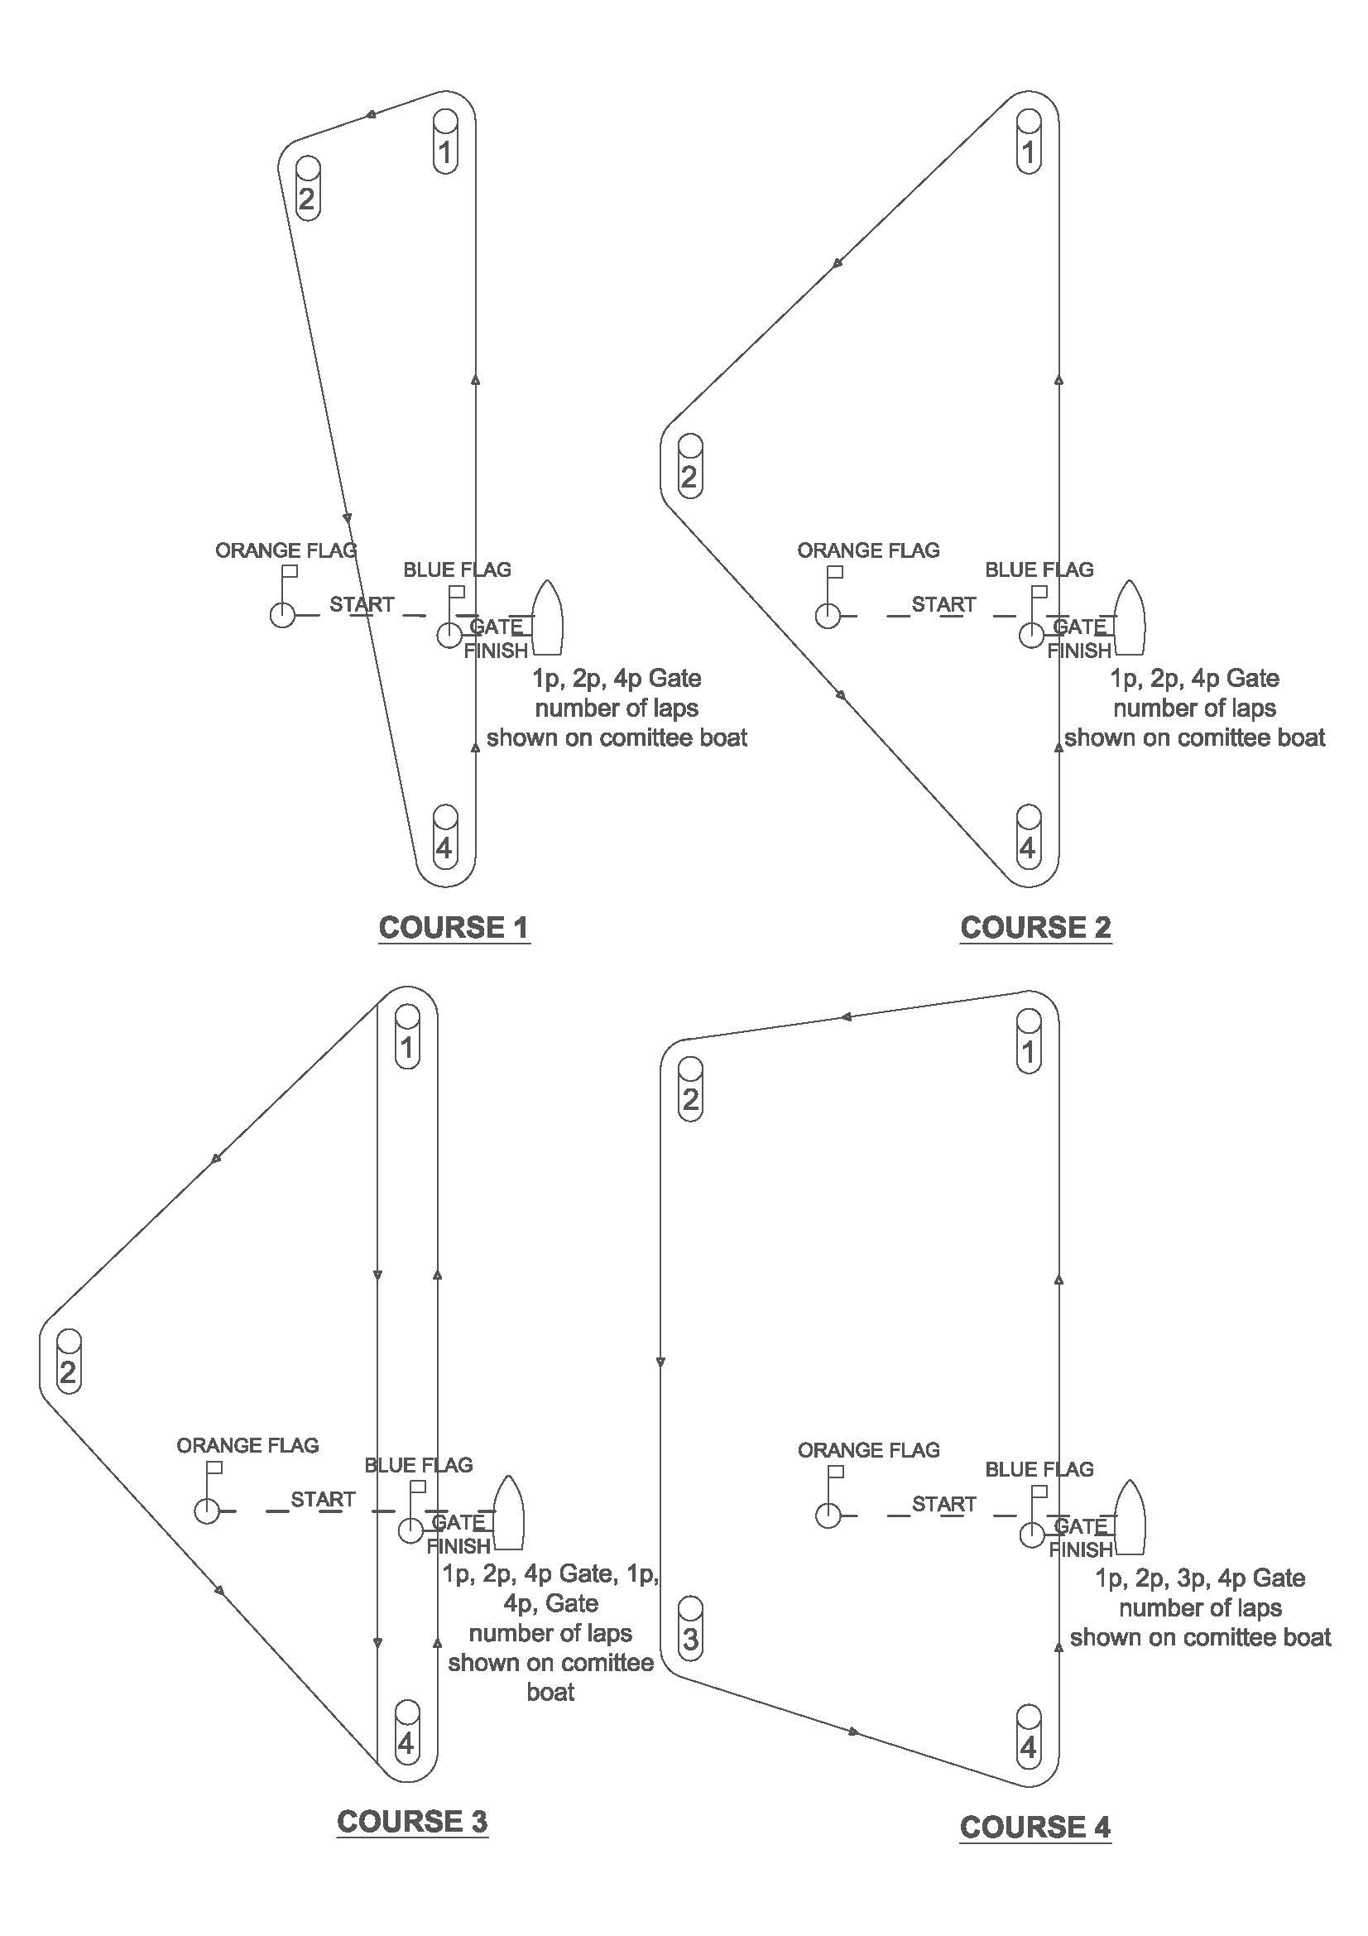The full course will comprise the number of rounds displayed on a board on the committee boat before a warning signal, plus a finishing leg from the final mark to the finishing line.

